Aws account creation step
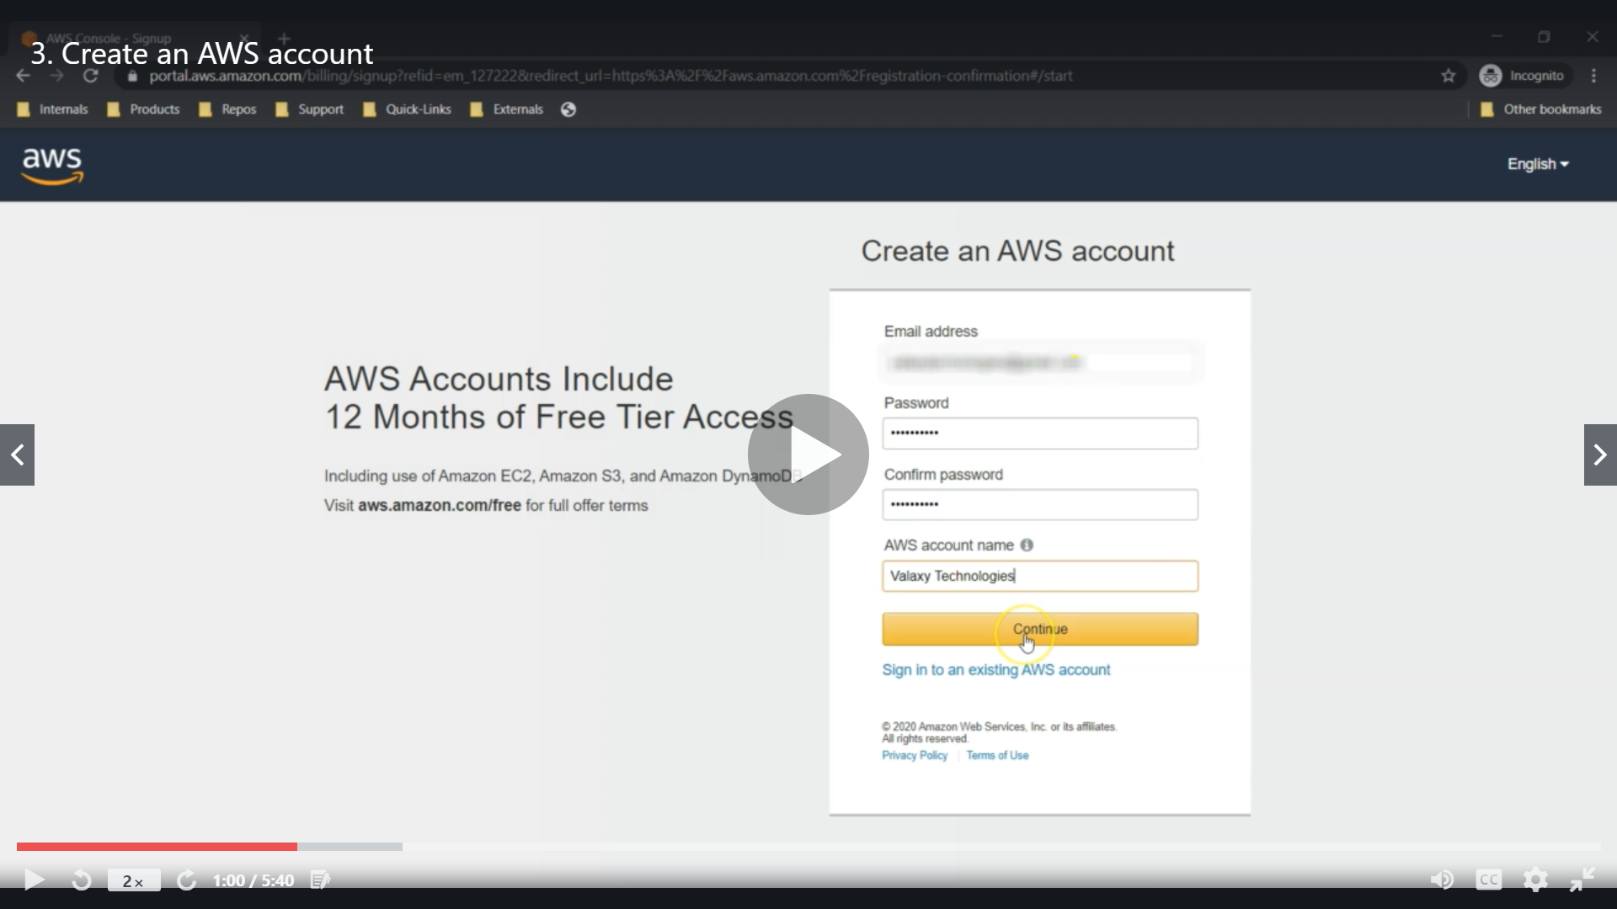
Creating an AWS Account is the first step you need to take in order to learn Amazon Web Services. Signing up for AWS provides you with all the tools you requite to become an AWS professional.
In this post, we will look at the step-by-step process of Creating an AWS Account.

Step 1 – Visiting the Signup Page
Head over to the Amazon Web Services website for Creating an AWS Account.
You should see something like below:
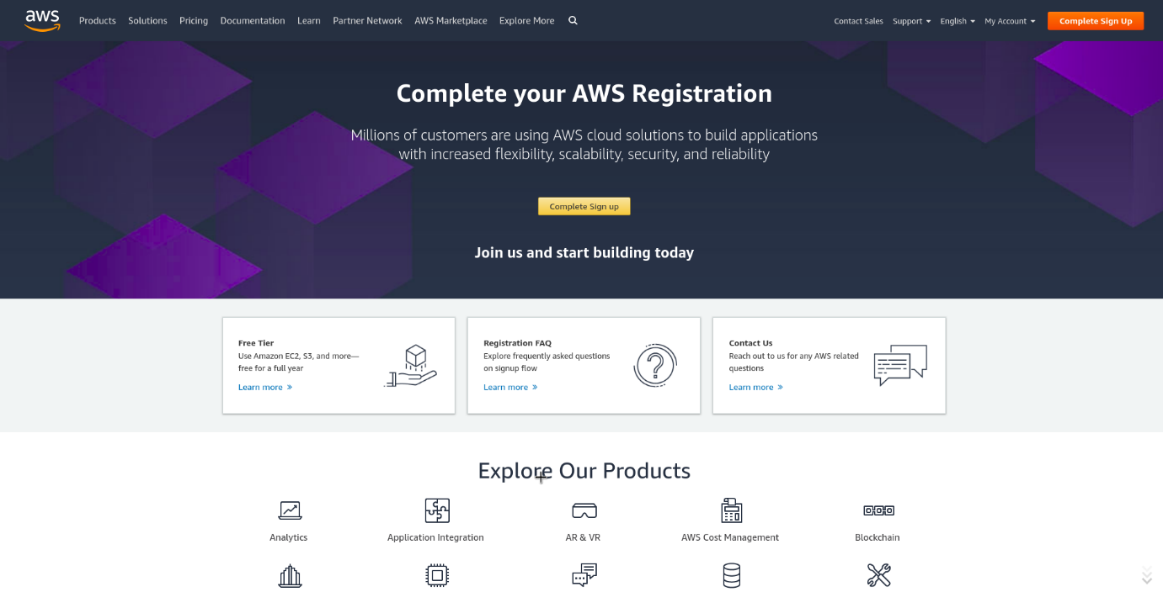
In order to continue, click the Complete Sign Up button in the middle of the screen or on the top right corner of the screen. You will see the below screen.
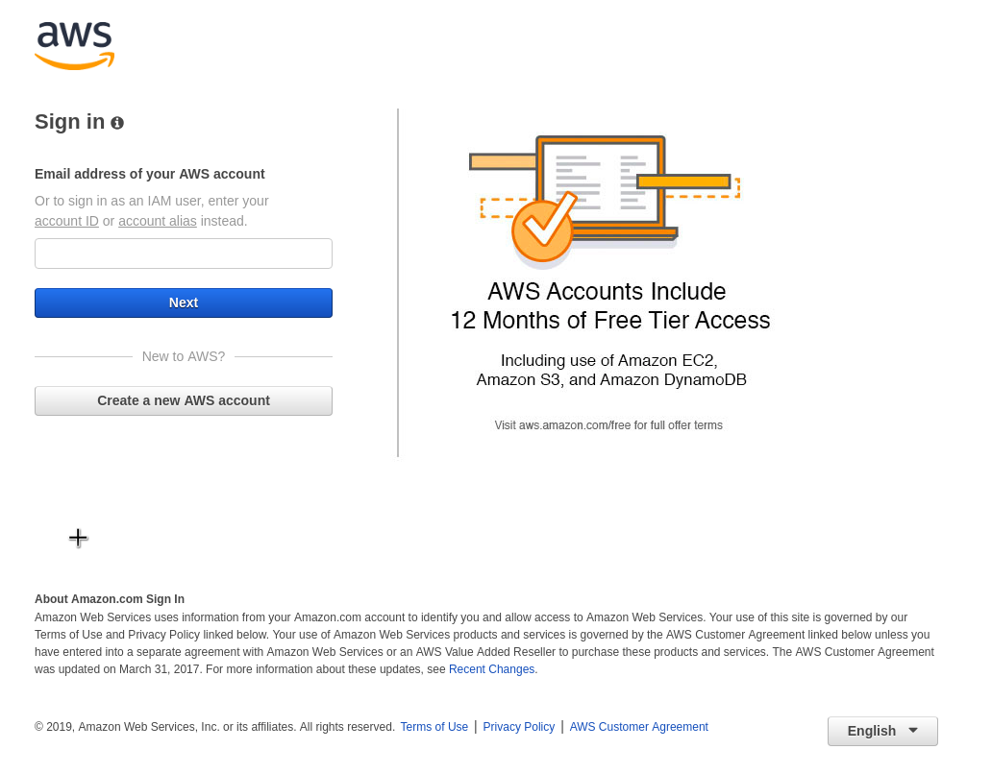
If you are an existing user, you can sign in. Or you can click on the Create a new AWS account button. On this screen, you can also select your language preference from the dropdown below.

Step 2 – Entering User Details
After you have chosen to Create a new AWS account, you will see the below screen asking for few details.
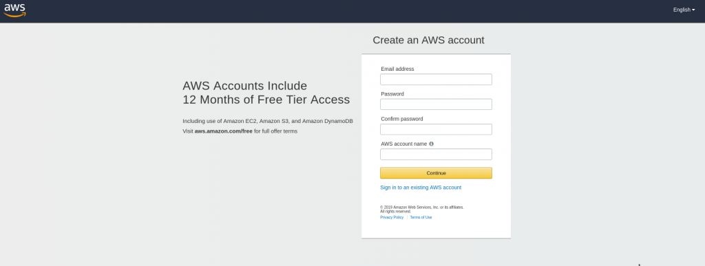
You can fill up the details as per your requirements and click Continue.
Next you will be asked to fill up your contact details such contact number, country, address and so on. You should fill them up properly because your contact number is important for further steps.
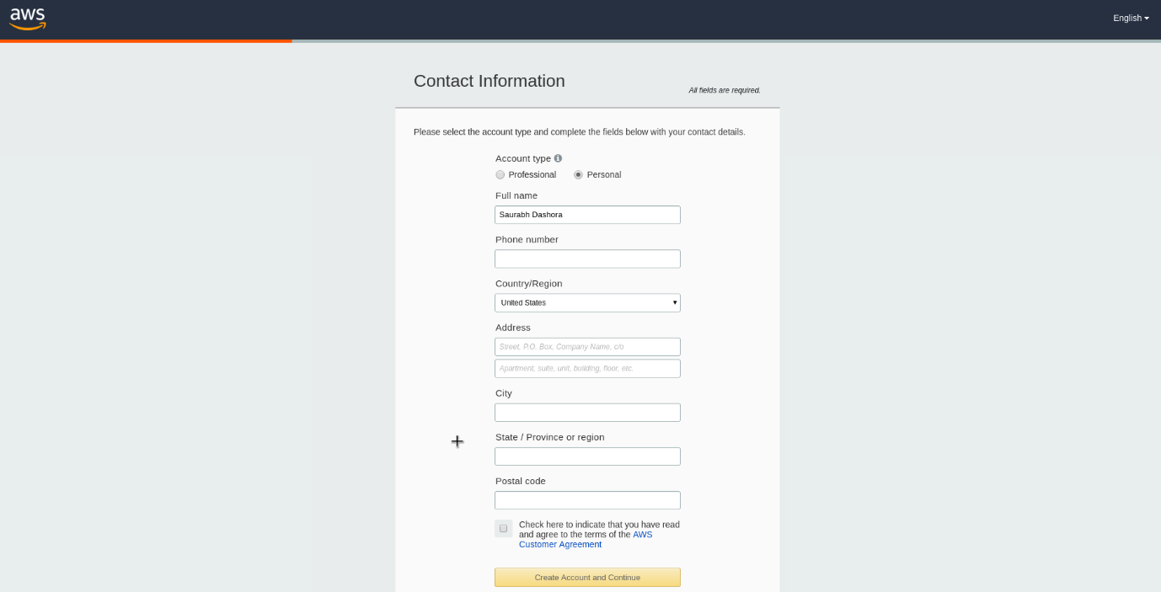
Note that unless you are creating an account for your organization, it is better to select Account Type as Personal.
After filling up the details, click on the Create Account and Continue button at the bottom of the form.

Step 3 – Filling up the Credit Card details
For Creating an AWS Account, you need to enter your Credit Card details.

However, don’t worry. This will not charge anything from your account (except for a verification amount that will be refunded back). But this is required in case you exceed the free-tier limit available with a new AWS Account.
After entering the details, click on Secure Submit button. It might take a while to process the request depending on your bank/credit card company servers.

Step 4 – Identity Confirmation
Once the credit card details are confirmed, you will need to complete the Identity Confirmation step. You will see the below screen:
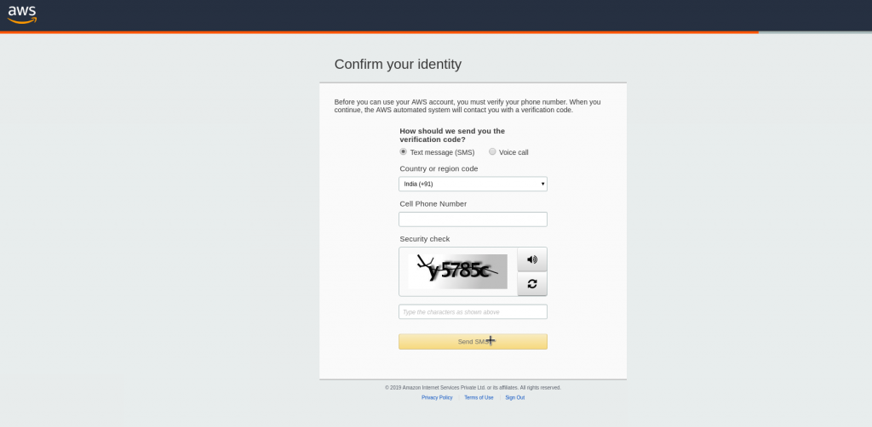
Basically, you need to select a mode to confirm your identity. It could be a Text Message or a Voice call to your valid phone number.
Once you have verified successfully, you should see a screen like below:

Click on Continue to proceed further.

Step 5 – Selecting a Support Plan
In the next step for creating an AWS Account, we need to select the plan for our AWS Account.

Unless you are planning to do some professional development, I would suggest selecting the Basic Plan. It is Free of cost and great for learning purposes.
The other plans are Developer Plan and a Business Plan. But both of them are paid options.
Once you select your plan, you will see the below Welcome screen. From here on, you can Sign in to your AWS Console.

Here, you also have the option of personalizing your experience of using Amazon Web Services.
However, you can also simply continue by clicking Sign in to the Console. After this, you will be again presented with the sign in screen where you can now use your credentials to login.
Finally, after logging in, you should be able to see the AWS Management Console as below:

If you have reached this far, you have successfully finished Creating an AWS Account.

Understand the AWS Free Tier
The great thing about Amazon Web Services is that you get a free tier when you create an account.
This is extremely useful if you want to learn AWS without spending money on provisioning servers and so on.
However, not all stuff available on AWS qualifies for Free. Also, there are categories such as Always Free and 12 Months Free.
You can get more details about them at this link.

In our series of learning AWS, we will try to keep ourselves within the free tier as much as possible.

Conclusion
We have now successfully finished creating an AWS Account and also verified it so that it can be used to learn AWS.
We also gave a brief look at AWS Free Tier and understood its benefits.
In the next post, we will learn about IAM.
If you have any queries till this point, sound off in the comments section below.
Happy Learning!

